No images? Click here
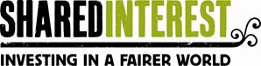
Hello and welcome to your latest volunteer update

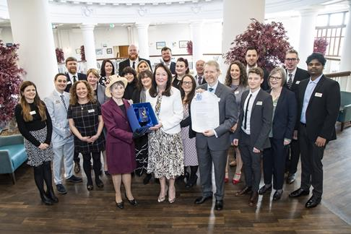
Newcastle staff gathered at a local event on 10th March to officially receive our belated Queen's Award for Enterprise in the Sustainable Development category, awarded in 2020.
Fast Facts
Keeping you up to date at a glance
Share Capital currently stands at £51.9 million with 10,486 Share Accounts.
Welcomes and Farewells
We are delighted to welcome Joanna to our Ambassador team and Alejandra to our Spanish Translator team. We also welcome Teo to the new role of Trusts and Foundations Researcher supporting Shared Interest Foundation.
We hope you find the information in this latest newsletter helpful. We try to include something for everyone and your thoughts on what's good and what needs improving are always welcome - we would love to hear your feedback.

AWARDS
Queens Award for Enterprise in the Sustainable Development category
Although we received this in 2020 we were finally able to accept the award at a local event on the 10th March attended by our Newcastle team who were joined virtually by our overseas colleagues. The Lord Lieutenant for Tyne and Wear, the Queen's representative in the region, presented the award to Managing Director Patricia Alexander with staff and Board in attendance.
WISE100
The annual WISE100 list, created by Pioneers Post in partnership with NatWest Social & Community Capital, was announced in March, naming the top 100 women in social enterprise across the UK. Shared Interest MD, Patricia Alexander, has featured in the list since 2018, was also shortlisted in the category of Social Impact Champion. You can read more HERE


Your questions answered
In this regular feature, we hope to answer many of the FAQs you may encounter when talking to friends, family or the public about our work.
In which countries does Shared Interest operate?
In addition to our Head Office in Newcastle, we have regional offices in Kenya, Ghana, Peru and Costa Rica. We lend to customers across the world and our customers are concentrated in the regions covered by our regional offices - East Africa, West Africa, South America and Central America. You can read more about the countries where our customers are based in our Social Accounts available HERE
We are not currently able to lend money directly to producers in India, Bangladesh, Pakistan or Nepal due to exchange control legislation, but we do make payments to fair trade producers across the region on behalf of our fair trade buyers.
If you have a question you would like answered please submit it to us at volunteers@shared-interest.com
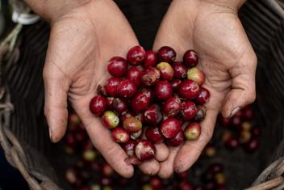
Longitudinal Case Studies
Each year we carry out Longitudinal Case Studies to understand the impact of our lending on producer organisations and their communities. These in depth studies help us understand whether we are fulfilling our mission of contributing to make living standards and livelihoods better for people as they trade their way out of poverty.
This year we are developing studies of three coffee organisations: Coagricsal in Honduras, COOPARM in Peru and KOAKAKA in Rwanda. The studies involve background research, surveys and interviews and provide a wealth of information for our communications. You can read previous Longitudinal Case Studies in Social Accounts and keep an eye out for more information on these three studies later in the year. Thank you to those of you who have assisted us with research and translations so far.
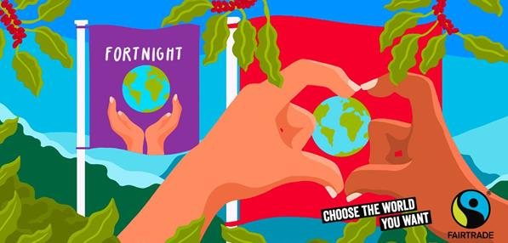
What's been happening and what's on the horizon
A round up of recent and upcoming activity
Fairtrade Fortnight always marks a busy time for everyone involved in Shared Interest and this year we started to see a return to face to face events. Many of you got involved in some way, whether attending some of our online regional events, running a stall in your local area or speaking to groups online. You can watch recordings of many of the events which took place during Fairtrade Fortnight, including those hosted or supported by Shared Interest, HERE You'll also find some great coverage of Shared Interest in North East publication The Chronicle HERE
International Women's Day (IWD) was celebrated around the world on the 8th March with the theme Break the Bias. The World Fair Trade Organisation led the social media action for the fair trade movement on the day with their campaign #sheleadstheway. You can find some of the images shared for IWD by searching the #BreaktheBias or #Sheleadschange hashtags on social media.
We're holding our second Volunteer Impact Webinar on Thursday 31st March at 2.30pm via Zoom. If you'd like to join us please let us know and we will share the Zoom link. We will be recording the webinar to share afterwards.
GREENBELT - 26th - 29th August 2022: We are currently making small steps back into attending outdoor events, to raise the profile of Shared Interest. There is an opportunity for us to have a stall at Greenbelt Festival in Northamptonshire but we need a team of volunteers to help us. Please contact volunteers@shared-interest.com if you would like further information on how to get involved.
We will be carrying out a Volunteer Survey in the coming months so keep an eye on your inbox for this. We really appreciate your time completing this as your responses help us develop and improve volunteer involvement at Shared Interest.
What we've been reading, watching and listening to
A round up of what's caught our attention recently.
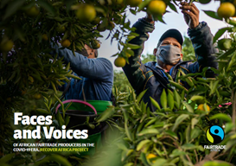
BUILDING BETTER BUSINESS PODCAST. Building Better Business explores how we can all take a step towards creating a more sustainable and socially conscious world through enterprise. Hear John Steel CEO of Cafédirect talk to those leading the way and uncover how business can be an instrument for positive change for shared and durable prosperity.
RECOVER AFRICA PHOTOBOOK. The RECOVER Africa Project was implemented by Fairtrade Africa. The project aimed at mitigating the impact of the COVID-19 pandemic on producers health, wellbeing and economic sustainability. The projects interventions have benefitted over 600,000 Fairtrade farmers and workers in nine countries in Africa, namely: Ghana, Côte D’Ivoire, Madagascar, South Africa, Malawi, Rwanda, Kenya, Uganda and Tanzania. This photo book shares the stories of some of the project participants.
EATING OUR WAY TO EXTINCTION another recommendation from Ambassador Phil and available to watch on a variety of platforms. Confronting and entertaining, this documentary allows audiences to question their everyday choices, industry leaders and governments. Featuring a wealth of world-renowned contributors, including Sir Richard Branson and Tony Robbins, it has a message of hope that will empower audiences.

Our mission is to provide financial services and business support to make livelihoods and living standards better for people as they trade their way out of poverty.
By volunteering for a fairer world, you make the difference.
Thank you.

